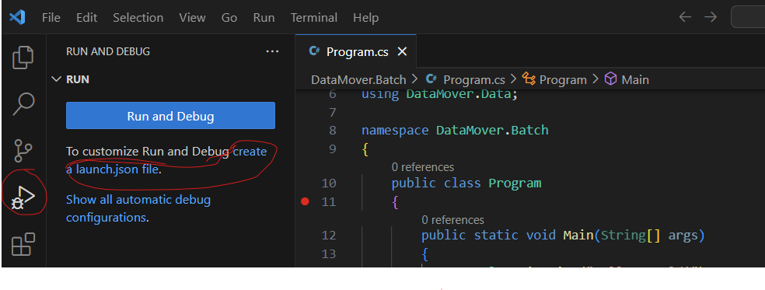

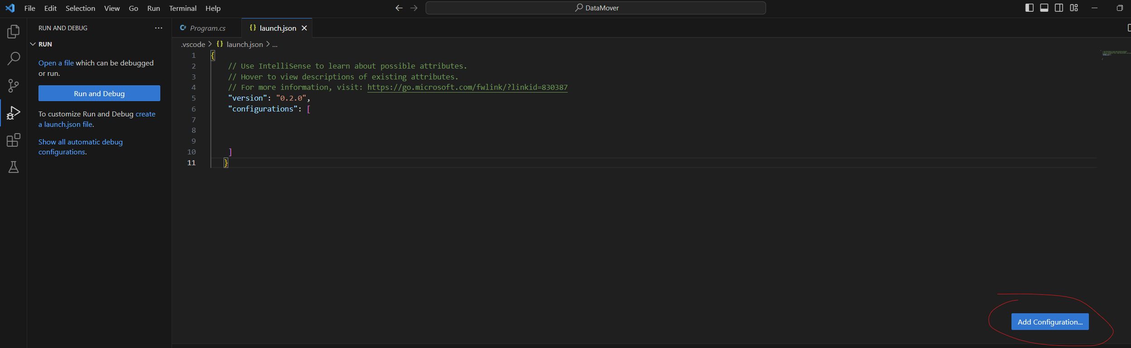

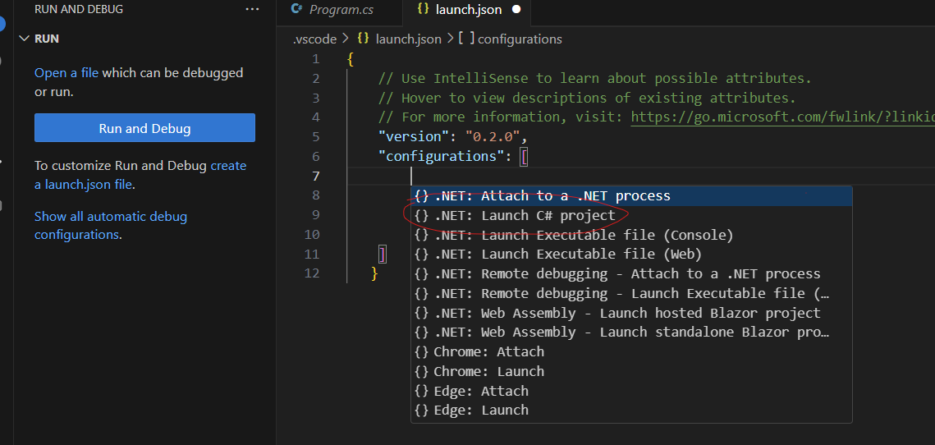

Launch.json file content.

{

// Use IntelliSense to learn about possible attributes.

// Hover to view descriptions of existing attributes.

// For more information, visit: https://go.microsoft.com/fwlink/?linkid=830387

"version": "0.2.0",

"configurations": [

{

"name": "C#: DataMover.Batch Debug",

"type": "dotnet",

"request": "launch",

"projectPath": "${workspaceFolder}\\DataMover.Batch\\DataMover.Batch.csproj"

}

]

}